Keeping You and Your Kids Moving
Formulas Below

GET KIDS MOVING
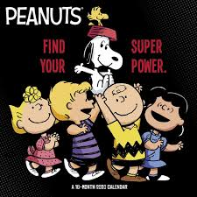
Train with your favorite superhero, a Jedi, or practice wizarding skills. https://www.youtube.com/channel/UCokO71NW3TgndaSNyHIqwtQ

Cosmic Kids Yoga For kids aged 3+
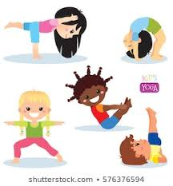
https://www.youtube.com/user/CosmicKidsYoga

Darebee work out
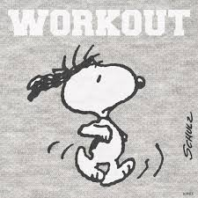
Schedule, what exercise, how long, level? Specific body work out you want Choose. Make it your own. (turn on some tunes, puts extra energy into your moves)
https://darebee.com/

Google, YouTube Just Dance
Pick one, two, three or all the many dances and show your mojo moves!
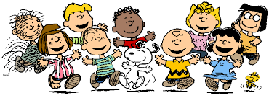

Sworkit Kids work out
https://app.sworkit.com/collections/kids-workouts

Fitness Blender Middle school and older
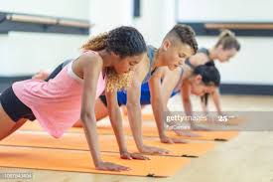
Many options to choose from to customize your work out.
https://www.fitnessblender.com/plans

